Why Stuff Happens

- Recap

Consider the following reactions. State if the reactants or products have higher/more entropy:

- CaCO₃ (s) CaO (s) + CO₂ (g) . . . . . . . . . . . . . . . . . . . . . . . . . . . _______________

- N₂ (g) + 3H₂ (g) 2NH₃ (g) . . . . . . . . . . . . . . . . . . . . . . . . . . . . . _______________

- CH₃COO⁻Na⁺ (aq) CH₃COO⁻Na⁺ (s) . . . . . . . . . . . . . . . . . . . . _______________

- NaCl (s) NaCl (aq) . . . . . . . . . . . . . . . . . . . . . . . . . . . . . . . . . . . . _______________

- 2H₂O (l) 2 H₂ (g) + O₂ (g) . . . . . . . . . . . . . . . . . . . . . . . . . . . . . _______________

- Axiom

We expect a system to go from a less to more stable state.

Increased stability implies a . . . . . . . . . . . . . . . . . energy state.

Which is the better choice, exothermic or endothermic, when considering if a reaction will take place or not?

. . . . . . . . . . . . . . . . . . . . . . . . . . . . . .

Why do you say this?
Sketch a simple diagram to explain your choice.

- Demonstrations

- The Imploding Bottle (NaOH and CO₂)

Question | Observation/Answer
Upon addition of the tablets, a whole lot of CO₂ (g) was produced. At this point, is the entropy of the system high or low?
What changed upon adding NaOH (aq)? What can you say about the entropy change of the system?

Was the bottle warm to the touch? What does this tell us about the enthalpy change of the reaction or system?

Write the chemical reaction for this reaction. State if the entropy increased or decreased on going from reactants to products.

- Solid and Solid (BaCO₃ and NH₄Cl)

Question | Observation/Answer
How did the consistency change upon mixing the two solids together? How is the entropy changing?
Was there any gas evolved? What was it?

What special “heavy lifting” could the beaker do? Why could it do this? What was the enthalpy change?

Write the chemical reaction for this reaction. State if the entropy increased or decreased on going from reactants to products.

So what’s “strange” here?

What’s the missing link and why do things happen?
- The Second Law of Thermodynamics (The Crux of It All)

The entropy of the universe always increases in the course of a spontaneous reaction.

dS_{univ} > 0

dS_{univ} = dS_{sys} + dS_{surr}

What is entropy?

Entropy is defined as the extent or degree of disorder in a system. The higher the disorder or the more random the system is (i.e. more permutations to configure its constituent particles) the higher the entropy.

What can we do or supply to bring the system from the representation on the left to that on the right (see Figure 1)?

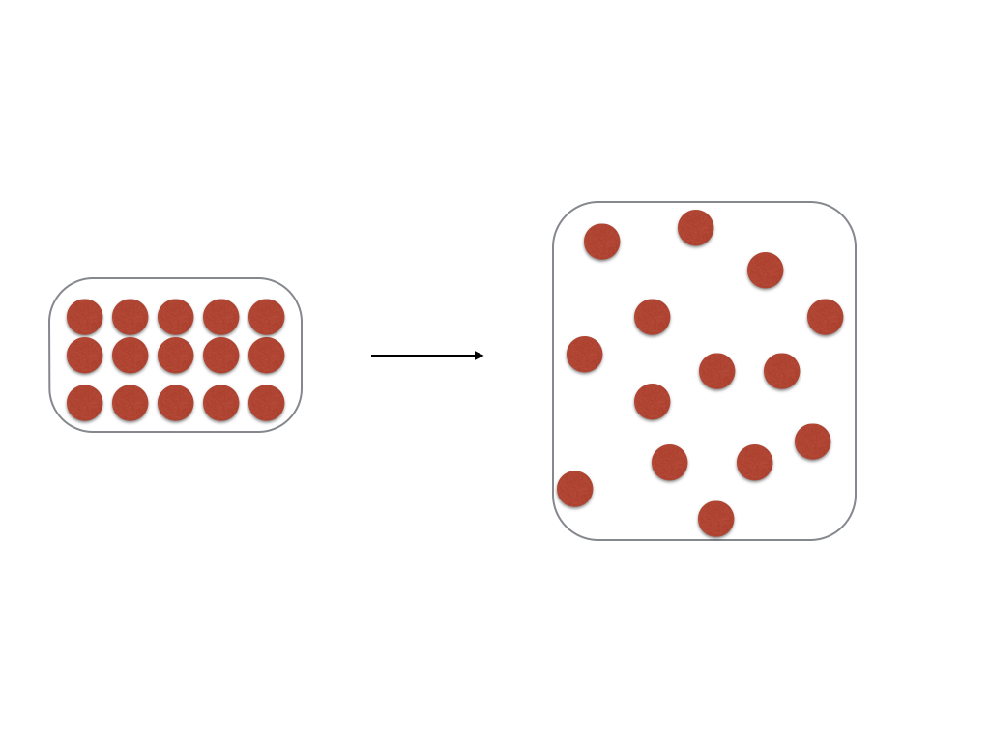
Figure 1 - Change in disorder

. . . . . . . . . . . . . . . . . . . . . . . . . . . . . . . . . . . . . . . . . . . . . . . . . . . . . . . . . . . . . . . . . . . . . . . . .

The more . . . . . . . . . . . . or . . . . . . . . . . . . . . . . . . . . . . supplied, the . . . . . . . . . . . . . the entropy.

It seems like the change in entropy is . . . . . . . . . . . . . . . . . proportional to

the . . . . . . . . . . . . . . . . . . supplied.

Now let’s consider the extent of the change of entropy.

Draw, in the space below, the change in organisation of particles on going from (a) 100 pK to 10 K and (b) 3000 K to 3010 K for any species (e.g. helium or silicon).

It seems like the change in entropy is . . . . . . . . . . . . . . . . . . . proportional to

the temperature at which the chemical or physical process occurs.

- Play with The Equation and Construct Meaning

In the following (generic and rather rough derivation), we see how we assign meaning to an equation by simply playing with it.

dG = -TdS_{univ}

Since dS_{univ} is greater than zero for a spontaneous change, we must have dG < 0 for the same spontaneous change (since T is absolute and is always greater than 0).

- Meaning!
Rearranging, we get:
dH = dG + TdS

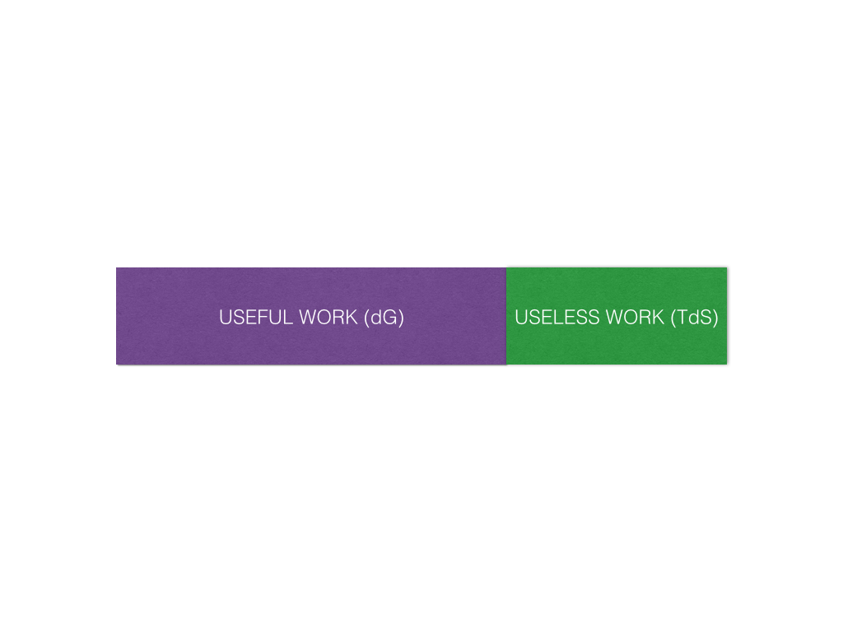
- dG and Equilibrium

The ‘drooping shoelace’

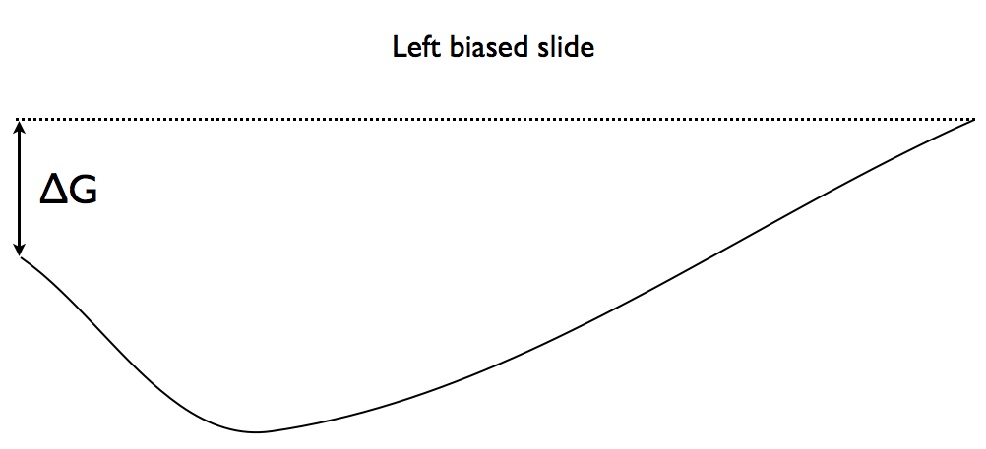
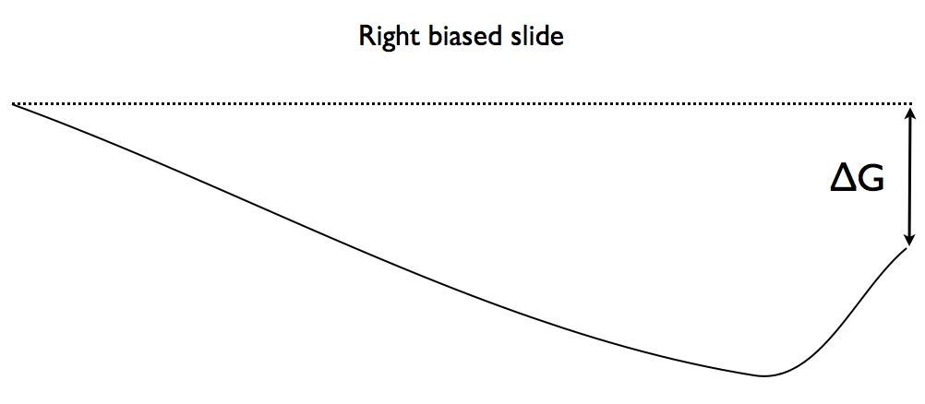
Are there reactants and products at the end of the reaction? . . . . . . . . . . . . . .

However, . . . . . . . . . . . . . . . . . . . . . . . . . . . . . . . . . . . . . . . . . . . . . . . . . . . . . . . . . . . . . . . .

. . . . . . . . . . . . . . . . . . . . . . . . . . . . . . . . . . . . . . . . . . . . . . . . . . . . . . . . . . . . . . . . . . . . . . . . . .

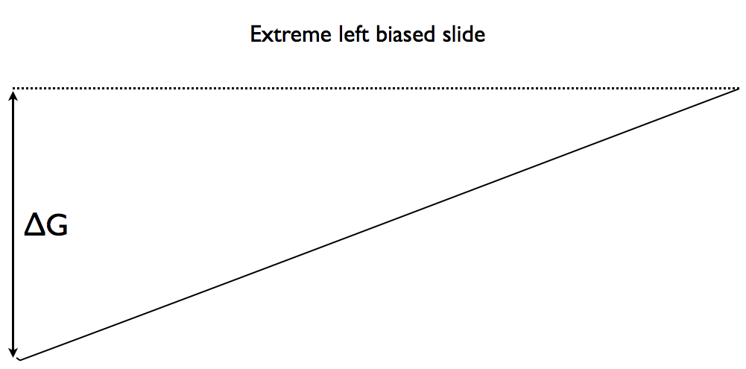

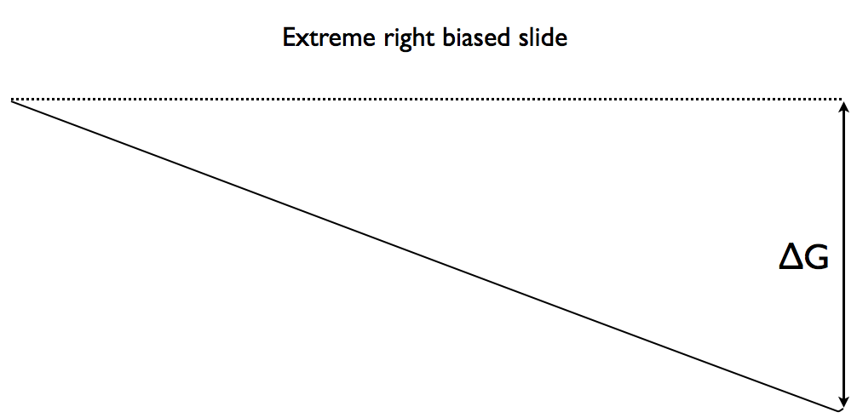
Are there reactants and products at the end of the reaction? . . . . . . . . . . . . . .

However, . . . . . . . . . . . . . . . . . . . . . . . . . . . . . . . . . . . . . . . . . . . . . . . . . . . . . . . . . . . . . . . .

. . . . . . . . . . . . . . . . . . . . . . . . . . . . . . . . . . . . . . . . . . . . . . . . . . . . . . . . . . . . . . . . . . . . . . . . . .

- Application to improving yields of reactions.

- Would you use a high or low temperature when carrying out organic synthesis of the form A + B C (where all are in the same state/phase)

. . . . . . . . . . . . . . . . . . . . . . . . . . . . . . . . . . . . . . . . . . . . . . . . . . . . . . . . . . . . . . . . . . . . . . . . . .

. . . . . . . . . . . . . . . . . . . . . . . . . . . . . . . . . . . . . . . . . . . . . . . . . . . . . . . . . . . . . . . . . . . . . . . . . .

- Would you use a high or low temperature when carrying out synthesis of the form A B + C (where C is in the gaseous state and A & B are in the solid state).

. . . . . . . . . . . . . . . . . . . . . . . . . . . . . . . . . . . . . . . . . . . . . . . . . . . . . . . . . . . . . . . . . . . . . . . . . .

. . . . . . . . . . . . . . . . . . . . . . . . . . . . . . . . . . . . . . . . . . . . . . . . . . . . . . . . . . . . . . . . . . . . . . . . . .

- Permutations

dH | dS | dG | Feasibility
- | + | - | Spontaneous
- | - | ? (Depends) | Temperature dependency
+ | + | ? (Depends) | Temperature dependency
+ | - | + | Not spontaneous

- Problem

Try to prove the most overlooked statement: Thermal energy ‘flows’ from high to low temperature (clue: 2nd Law).

